RESOLUTION NO.__________

RE: CERTIFICATE OF APPROPRIATENESS UNDER THE
PROVISIONS OF THE ACT OF THE PENNSYLVANIA
LEGISLATURE 1961, JUNE 13, P.L. 282 (53
SECTION 8004) AND BETHLEHEM ORDINANCE NO.
3952 AS AMENDED.

WHEREAS, it is proposed to install illuminated signs and to also install an awning/roof over the rear exit at 226 E. 3rd St.

NOW, THEREFORE, BE IT RESOLVED by the Council of the City of Bethlehem that a Certificate of Appropriateness is hereby granted for the work.

Sponsored by: (s)

(s)

ADOPTED BY COUNCIL THIS DAY OF

(s)
President of Council

ATTEST:

(s)
City Clerk

HISTORIC CONSERVATION COMMISSION

CASE # 457 – It is proposed to install illuminated signs and to also install an awning/roof over the rear exit at 226 E. 3rd St.
OWNER/APPLICANT: Alejandrino & Carmen Trujilo / Kevin Luna

The Commission upon motion by Mr. Roeder seconded by Mr. Cornish adopted the proposal that City Council issue a Certificate of Appropriateness for the proposed work described herein:

- The proposal to install illuminated signs and to also install an awning/roof over the rear exit at 226 E. 3rd St. was presented by Kevin Luna.

- The new roof will be hipped and covered with a standing seam metal roof in a brown or tan color to blend with the new color scheme. It will be approximately 7’-4” x 12-1” in size. The overhang on the side will be about 4” and on the end about 2’. Half-round aluminum gutter and round downspout will be installed.

- The fascia may be clad in aluminum of “break metal thickness”, or finished with painted wood or Azek. The soffit and ceiling will be vinyl beaded soffit with invisible vents in a color to blend with the new colors.

- The 6 x 6 post will be wrapped with Azek and painted to blend with the proposed color scheme for the building.

- There will be a 42” high metal guard (steel or aluminum) with vertical pickets around the depressed loading area as shown in the drawings submitted to the HCC.

- The proposed illuminated signs will be solid aluminum channel letters with LED lighting inside and clear polycarbonate backs. The letters will be mounted off the walls with spacers so that the light creates a halo effect at night.

- There is a water absorption problem with the previously approved marble; porcelain tile may be substituted, but needs to look similar to the previously approved stone. The tile choice needs to be approved by the Historic Officer.

- The proposed motion was unanimously approved.

CU: cu

By: 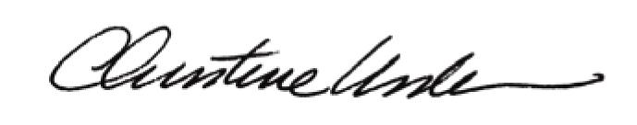

Date of Meeting: July 15, 2013 Title: Historic Officer

